

**ADAMA SCIENCE AND TECHNOLOGY UNIVERSITY**

**DEPARTMENT OF SOFTWARE ENGINEERING**

**Course: Mobile Application Design and Development**

**Course code:SEng 3206.**

**Group Project Documentation**

**Title:**Mode scope AI-Powered Emotional Analytic & Diary Platform

1. **Bereket Ketema…………………ugr/30265/15**
2. **Ephrem Mesfin………………….ugr/30473/15**
3. **Awel Kassim…………………..…ugr/30198/15**
4. **Bilal Ali…………………..……….ugr/30309/15**
5. **Adriano Girma………………….ugr/30115/15**

**6. Zerihun Edmealem……………..ugr/31480/15**

**Submitted to: Mr yared Tekalegn**

**Submission date: 2/05/2025**

# ****Mode Scope – AI-Powered Emotional Analytic & Diary Platform****

## ****1. Project Overview****

**Mode Scope** is a groundbreaking mobile application that redefines how individuals engage in journaling. It blends the introspective practice of writing with the analytical capabilities of **Artificial Intelligence (AI)** to produce meaningful emotional insights. Central to its operation is **Natural Language Processing (NLP)**, which allows the app to comprehend and interpret the emotional undertones embedded in users’ diary entries.

Once the sentiment is identified, Mode Scope conveys it using **emoji-based representations** and offers **interactive visual feedback** through graphs and charts. These features empower users to track their emotional journey, spot trends, and become more self-aware over time.

### 🌟 ****Problem Statement****

Many people struggle with recognizing and tracking their emotional well-being. Journaling can help, but most traditional journaling apps lack features that **analyze and visualize emotions** in a helpful way. Mode Scope addresses this by offering:

**AI-powered sentiment detection**

**Instant visual feedback**

**A clean and intuitive writing environment**

### 🎯 ****Target Audience****

**Mental Health Enthusiasts**  
Individuals seeking tools for self-reflection and emotional well-being.

**Productivity Seekers**  
Professionals aiming to analyze emotional patterns for personal growth and better performance.

**General Journalers**  
People who journal regularly and want added value through emotional insights.

## ****2. User Requirements****

User expectations guided the app’s feature set. These core requirements ensure that the product remains relevant, useful, and easy to use.

### **a. Emotional Awareness**

Users want to **understand how they feel daily**.

Expect **immediate feedback** that is engaging and visually appealing.

Emotions should be presented in a **clear and accessible format**.

### **b. Simplicity and Ease of Use**

Journaling should feel **natural** and free from complexity.

The app should automatically detect emotions, requiring **no manual tagging**.

Interface must remain **minimal and clutter-free**.

### c. Visual Feedback and Trend Monitoring

Users want to **track emotions over time**.

The app should provide:

**Bar graphs**

**Line charts**

**Pie charts**

**Calendar heatmaps**

Trends should be **easy to interpret** at a glance.

### d. Privacy and Data Security

Diary content is personal and must be protected.

Users should have:

**Local storage options**

**End-to-end encryption**

**Control over data access**

### e. Accessibility Across Devices

Expect full compatibility with:

**Android**

**iOS**

App must offer:

**Unified UI/UX**

**Responsive layout**

**Smooth performance on all screen sizes**

## ****3. Design Concepts****

Mode Scope embraces a design philosophy centered on **calm, simplicity, and emotional clarity**. The visual and experiential design works together to make journaling feel effortless and emotionally validating.

### a. User Interface (UI)

**Minimalistic Aesthetic**  
Uses whitespace and soft contrasts to avoid overwhelming users.

**Typography**  
Rounded fonts create a sense of safety and warmth.

**Emotion-Based Color Mapping**

Joy → Green

Anger → Red

Sadness → Blue

Neutral → Gray  
These are used in **emojis, graphs, and heatmaps**.

### 🧭 b. User Experience (UX)

**Immediate Journal Access**  
Users can write as soon as they open the app.

**Real-Time Sentiment Feedback**  
Detected emotions appear as **emoji badges** right after entry submission.

**Intuitive Navigation**  
A simple **bottom-tab menu** gives instant access to:

Diary

Charts

Settings

### 🌈 c. Visual Elements

**Emoji Feedback**  
Provides an **emotional shorthand** that is engaging and quick to grasp.

**Charts**  
Users can:

Switch between **weekly** and **monthly** views

Zoom and scroll

Compare days for pattern recognition

**Heatmaps**  
A **calendar view** visually represents mood intensity using:

Colors

Emojis

### d. Accessibility

**High-contrast themes**

**Text resizing options**

**Voice journaling** planned for future updates to aid differently-abled users.

## ****4. Development Approach****

Mode Scope was built using the **Agile development methodology**, ensuring flexible iteration and timely feedback integration.

### Key Phases of Development

**Requirement Gathering & Planning**

**UI/UX Wireframing**

**Feature Development (Agile Sprints)**

**Testing & Debugging**

**User Feedback Integration**

**Final Deployment & Optimization**

### Why Agile?

**Faster iterations**

**Rapid prototyping**

**Continuous delivery**

**User-driven design evolution**

### 🧩 Key Challenges & Solutions

**Real-Time Emotion Detection**

Challenge: Implementing accurate, instant mood recognition.

Solution: Used pre-trained NLP models and custom fine-tuning.

**Cross-Platform Consistency**

Challenge: Ensuring the same experience across Android and iOS.

Solution: Leveraged **React Native’s** responsive features and cross-platform components.

**Smooth Visual Rendering**

Challenge: Complex chart rendering without lag.

Solution: Adopted **lightweight charting libraries** and **optimized component lifecycle**.

## ****5. Technological Stack****

| **Layer** | **Technology** | **Justification** |
| --- | --- | --- |
| Frontend | React Native | Cross-platform support, rapid prototyping |
| Backend/API | Optional / Local Only | Uses **device storage** (AsyncStorage+postgres(modern sql based opensource database ) for privacy and speed |
| NLP/AI Engine | Custom Sentiment Logic | Based on **pre-trained models** (e.g., TensorFlow.js, spaCy) |
| Charting | Victory Charts / Recharts | Responsive, lightweight charts for mobile visualization |
| Dev Tools | Expo, VS Code, GitHub | Enhances development speed and team collaboration |

## ****6. Implementation Details****

### 🔧 a. Core Features

**AI-Powered Mood Detection**

User types a diary entry.

Entry is passed to an NLP engine.

Emotion is categorized (e.g., Joy, Anger, Sadness).

Result is stored and visualized.

**Emoji Mapping**

Emotion is visually represented by an appropriate **emoji**.

Displayed next to the diary entry.

**Charts & Trend Monitoring**

**Line graphs** show daily mood over time.

**Bar charts** for weekly emotional comparison.

**Heatmaps** visualize emotional intensity across the calendar.

**Offline-First Architecture**

**All data is stored locally** on the device.

No internet required.

Enhances privacy and reliability.

### 🖼 b. Screens & Descriptions

| **Screen** | **Function** |
| --- | --- |
| Home / Diary | A large text input titled "Write your day". Emoji shown after submission. |
| Mood Chart View | Interactive graph showing trends by day/week/month. |
| Heatmap View | Color-coded calendar displaying mood intensity. |
| Settings | Options to reset data, switch themes, and set mood reminders. |

## ****Diagrams****

Use case diagram

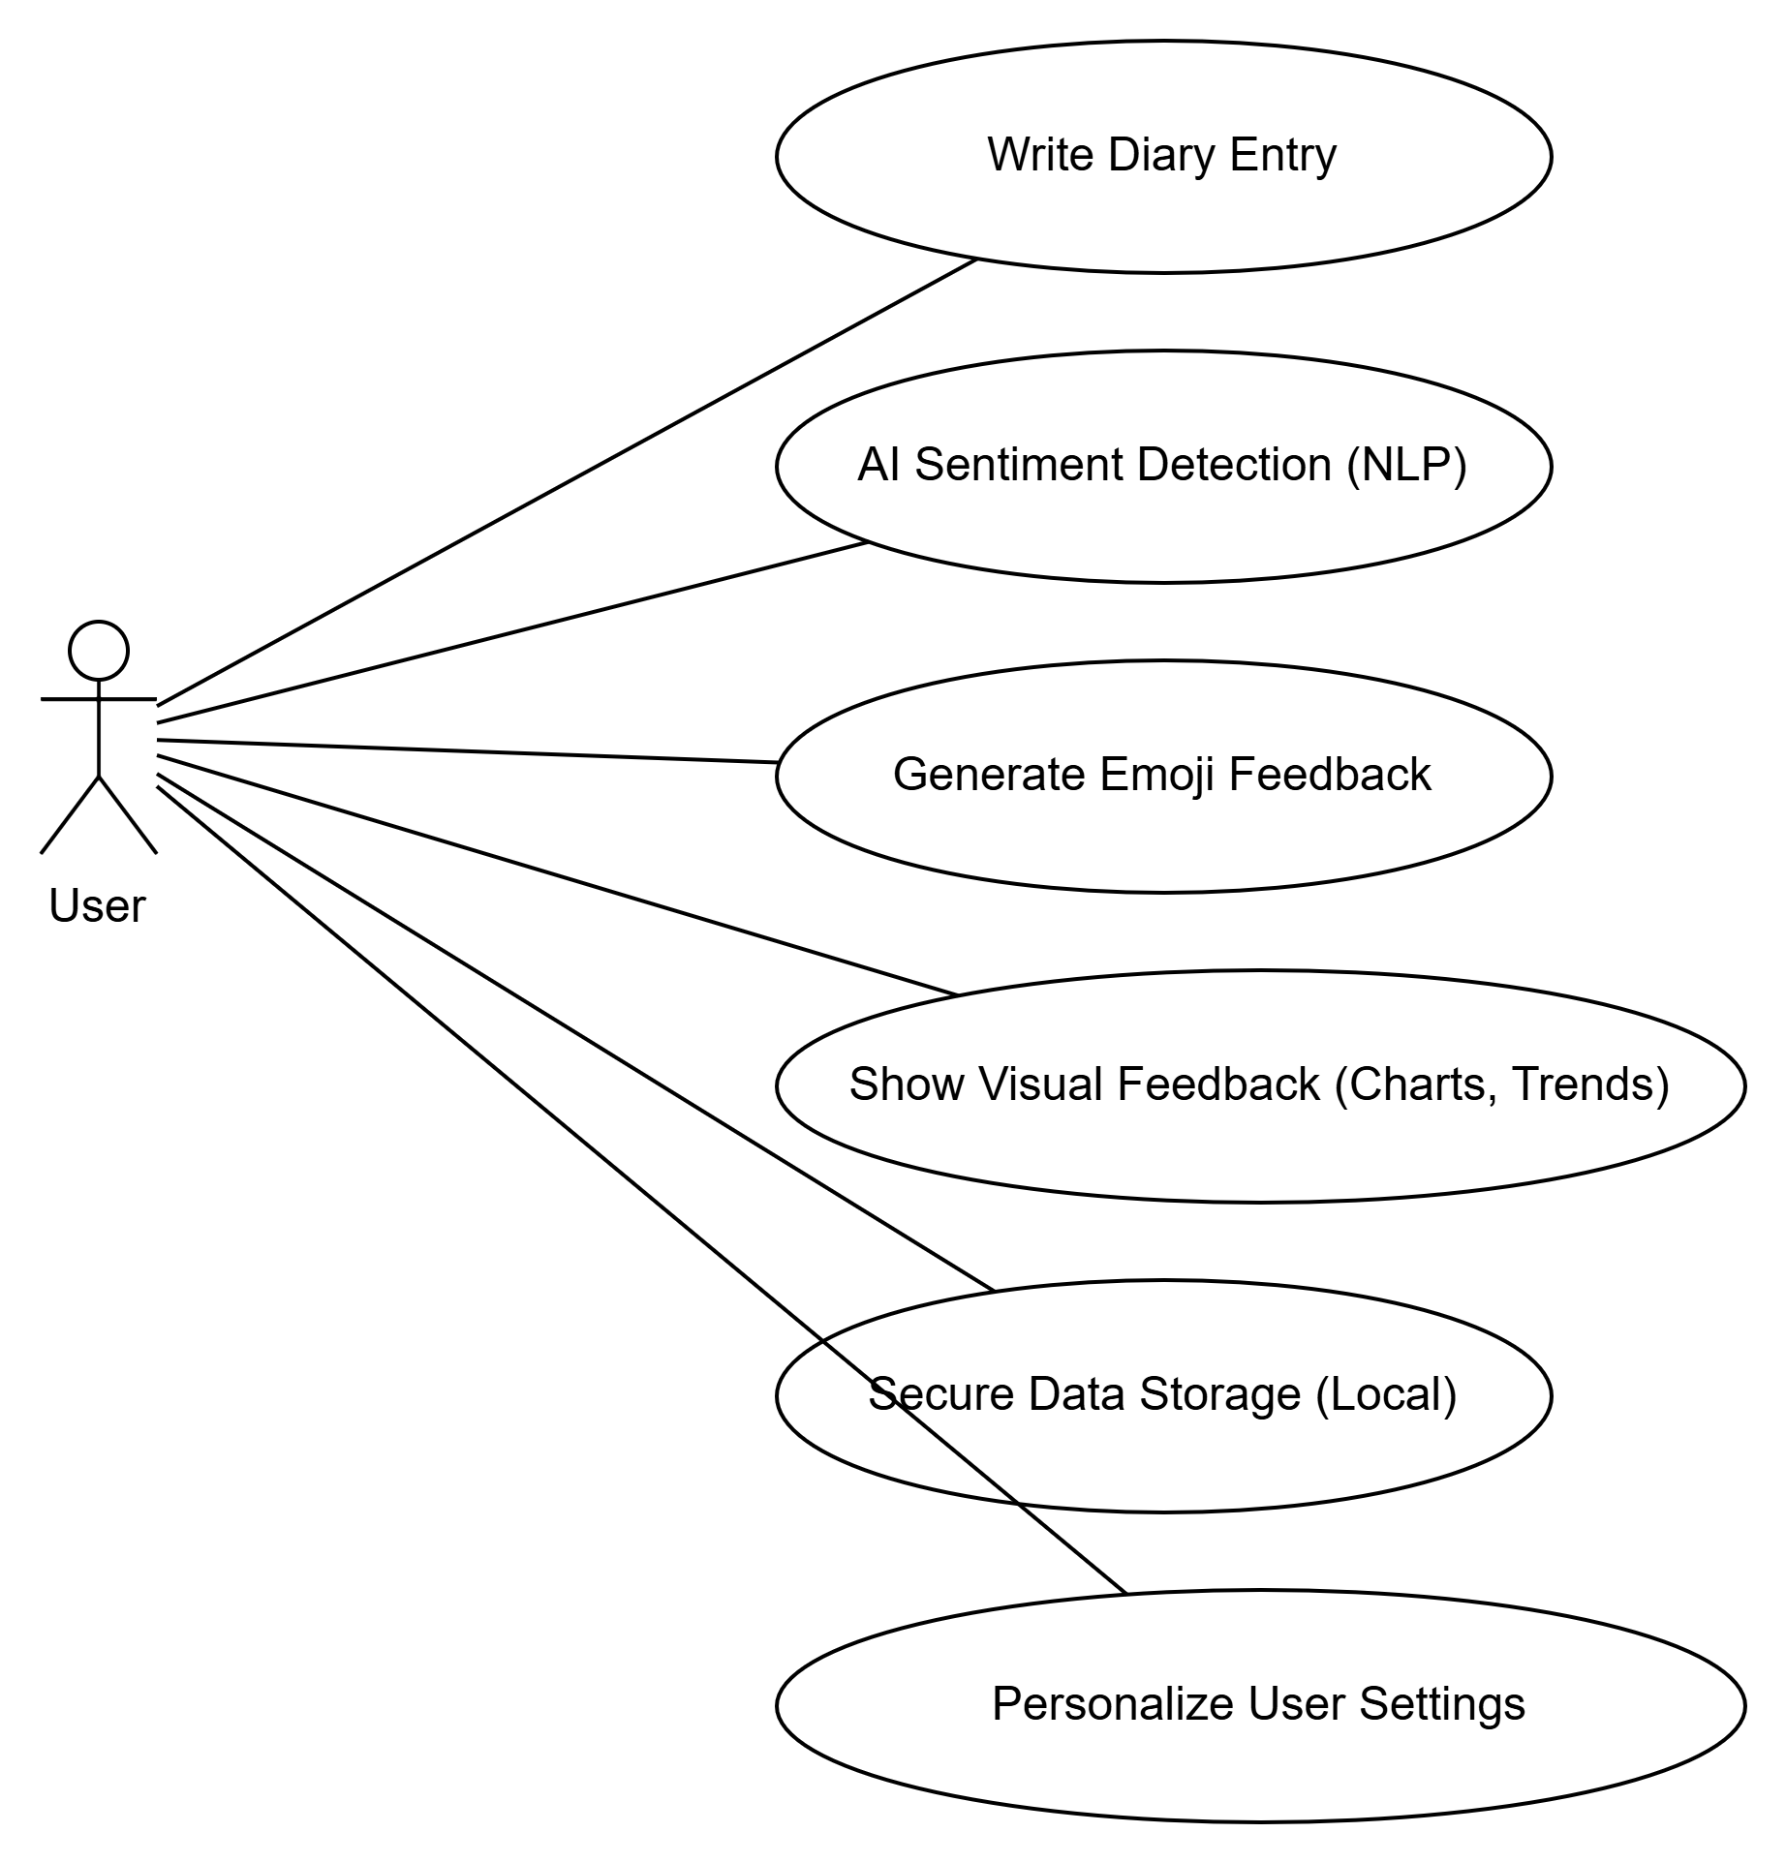

Figure 7.1 usecase diagram

The **Use Case Diagram** for the Mode Scope application highlights the interaction between the system (ModeScopeApp) and its external actors, specifically the **User**. It provides a visual representation of how users engage with the app, how the app processes their input, and how it generates outputs to help users track and understand their emotional journey.

#### Key Actors:

**User**: The primary actor in the system, interacting with the ModeScopeApp by writing journal entries and viewing feedback based on their emotions.

#### Use Cases:

**Write Journal Entry**:

The **User** writes a diary entry in the app, which is the starting point of the interaction with ModeScopeApp. This input is essential for further processing and sentiment analysis.

**Analyze Sentiment**:

The **ModeScopeApp** sends the user's journal entry to the **NLPModule**, which performs sentiment analysis using Natural Language Processing (NLP) techniques. It identifies the emotional tone (e.g., happy, sad, angry) from the text.

**Generate Emoji Feedback**

**Generate Visual Feedback**

**View Feedback**

#### System Components:

**ModeScopeApp**:

The core component of the system. It serves as the central point of interaction for the user, coordinating the various processes like sentiment analysis and feedback generation.

**NLPModule**:

A backend component that performs the sentiment analysis. It uses advanced Natural Language Processing algorithms to interpret the emotional content of the journal entries.

**EmojiFeedback**:

This module translates the identified emotion into an emoji that reflects the user's mood, offering a quick and intuitive visual representation.

**VisualFeedback**:

Provides more detailed visual feedback, such as graphs or charts, to give users insights into emotional patterns over time. This could include graphs showing mood trends or statistics reflecting emotional changes.

#### Relationships:

The **User** interacts with the **ModeScopeApp** by writing journal entries and receiving feedback.

The **ModeScopeApp** relies on the **NLPModule** to analyze the sentiment of the user's journal entries.

After sentiment analysis, the **ModeScopeApp** requests feedback from both the **EmojiFeedback** and **VisualFeedback** modules to give the user comprehensive emotional insights.

These relationships ensure a smooth flow of data and feedback, helping the user track and understand their emotional state over time.

Flow cahrt diagram

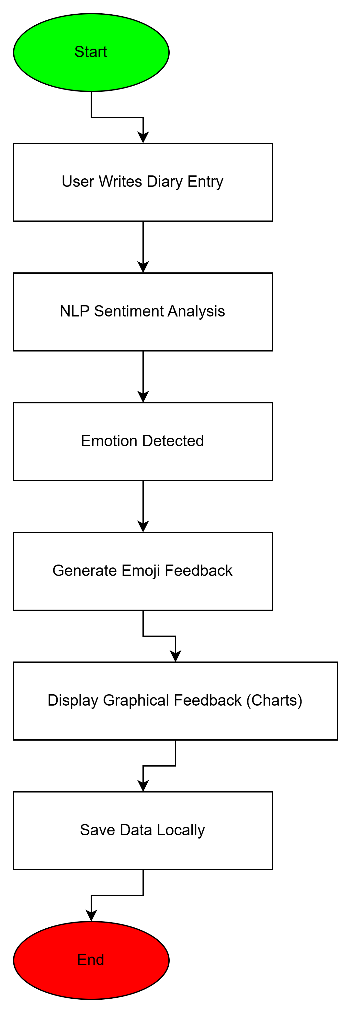

Figure 7.2 flow chart diagram

The **Flowchart Diagram** for the Mode Scope app visually represents the step-by-step process that takes place when a user writes a journal entry and receives emotional feedback.

**Start**:

The process begins when the **User** opens the app and starts writing a journal entry.

**Write Journal Entry**:

The user writes down their thoughts and feelings in the app's input field.

**Analyze Sentiment**:

Once the entry is submitted, the **ModeScopeApp** sends the text to the **NLPModule** for sentiment analysis.

**Sentiment Detected**:

The **NLPModule** analyzes the text and detects the emotional tone (e.g., happy, sad, neutral).

**Generate Emoji**:

Based on the detected sentiment, the app generates an appropriate emoji as quick visual feedback.

**Generate Visual Feedback**:

The app then generates detailed feedback, such as mood charts or graphs, to display emotional trends over time.

**View Feedback**:

The **User** views the feedback in the form of emojis and graphs to gain insights into their emotional state.

**End**:

The process ends, and the user can either continue journaling or exit the app.

This flowchart simplifies the sequence of actions involved in the mode detection process, highlighting the user experience from writing an entry to receiving feedback. It ensures a clear, step-by-step visualization of the app's functionality.

## ****Activity diagram****

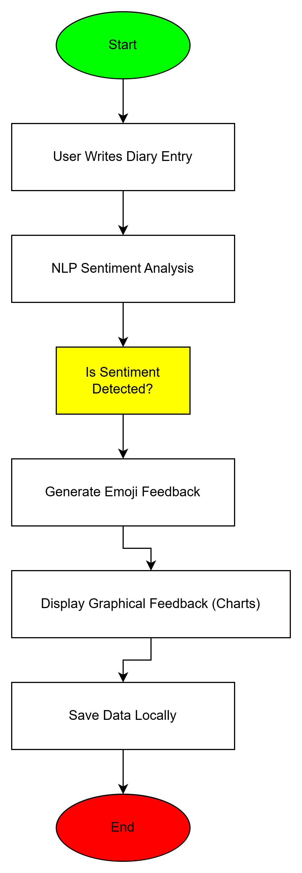

Figure 7.3 Activity diagram

The **Activity Diagram** for the Mode Scope app outlines the flow of activities involved in detecting and providing emotional feedback from a journal entry.

**Start**:

The process begins when the **User** opens the app and starts writing a journal entry.

**Write Journal Entry**:

The **User** inputs their journal entry in the app, detailing their emotions or experiences.

**Perform Sentiment Analysis**:

The app sends the journal entry to the **NLPModule** to analyze the emotional tone of the text.

**Detect Emotion**:

The **NLPModule** detects the sentiment (e.g., happiness, sadness, anger) from the journal entry.

**Generate Emoji Feedback**:

Based on the detected emotion, the app generates an emoji to visually represent the emotion.

**Generate Visual Feedback**:

The app then creates visual feedback (such as charts or graphs) to display emotional trends over time.

**User Views Feedback**:

The **User** views the emoji and visual feedback, helping them reflect on their emotional state.

**End**:

The activity flow ends, and the user can either continue journaling or exit the app.

This activity diagram illustrates the sequential steps and decision points in the mode detection process, ensuring a clear understanding of how the user interacts with the app and receives emotional insights.

****Sequence diagram****

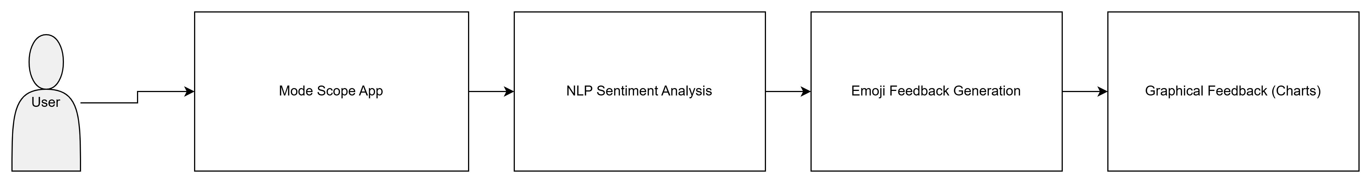

****Figure 7.4 sequence diagram****

The **Sequence Diagram** for Mode Scope outlines the dynamic flow of operations that occur during the mood detection process when a user submits a journal entry.

The process begins when the **User** initiates a diary entry within the app interface.

This entry is handed off to the **JournalProcessor**, which coordinates the backend logic.

The **JournalProcessor** sends the text to the **NLP Engine**, a component responsible for interpreting the emotional tone of the entry using pre-trained sentiment analysis models.

Once the **NLP Engine** returns the detected emotion (e.g., Joy, Sadness, Anger), the **JournalProcessor** engages the **Emoji Mapper** to convert the emotion into a corresponding emoji for user-friendly feedback.

The emotion and emoji are then presented to the **User**, and simultaneously passed to the **Visualization Module**, which updates the interactive mood charts and heatmaps.

This diagram effectively demonstrates the **real-time orchestration** between system components, emphasizing the **automated analysis and user-centric feedback loop** that Mode Scope is designed to deliver.

****Class diagram****

The **Class Diagram** outlines the structural relationships and data flow among core entities responsible for mood detection in the Mode Scope mobile application. Central classes include:

User – Represents the person using the app and holds preferences or settings.

JournalEntry – Captures and stores the textual diary input from the user.

NLPProcessor – Processes each journal entry using natural language techniques to detect sentiment.

Emotion – Categorizes detected mood (e.g., Joy, Sadness, Neutral).

Emoji Mapper – Maps each emotion to its corresponding emoji for visual representation.

Chart Manager – Handles the generation of interactive mood trend graphs and visual feedback

The relationships among these classes demonstrate a clear **division of concerns**, supporting clean architecture, easy maintenance, and future feature enhancements such as mood-based suggestions or wearable integration. The diagram helps developers understand how each component collaborates to provide users with meaningful emotional insights.

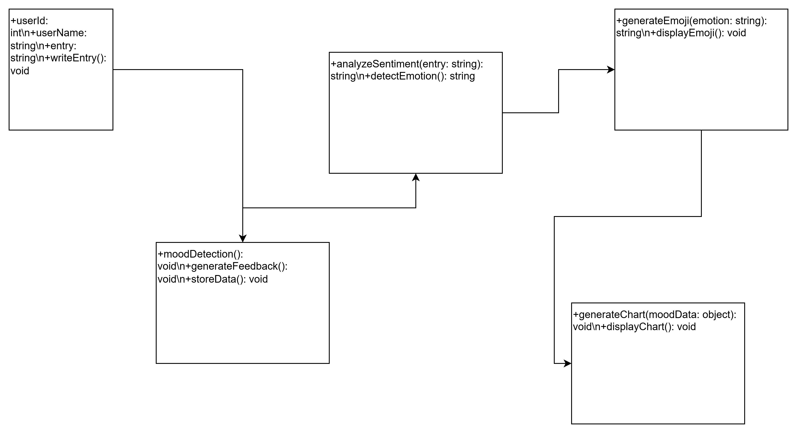

## ****Figure 7.5 class diagram****

## ****8. Testing and Quality Assurance****

### Types of Testing

**Unit Testing**

Targeted **emotion classification logic** and **chart rendering**.

**Integration Testing**

Ensured smooth interaction between NLP, UI, and storage layers.

**UI Testing**

Checked compatibility with different screen sizes and OS versions.

**Manual Testing**

Simulated user behavior to ensure smooth flow and feedback accuracy.

### Tools Used

**Jest** – for unit and integration testing

**Expo Go** – for real-time mobile previews

**Physical Devices** – for final platform testing

### Results

**NLP accuracy > 85%** for detecting general emotions

**Emoji feedback matched mood** in most cases

**Smooth rendering** across all tested Android and iOS devices

## ****9. Future Enhancements****

To further enrich the user experience and support long-term engagement, several future features are planned:

### 📈 a. Personalized Mood Tagging

Let users **edit or override AI tags**

Users can **create custom emotion labels** (e.g., “anxious,” “hopeful”)

### 🎙 b. Voice Input Journaling

Convert **speech to text** for hands-free journaling

Supports differently-abled users and users on the go

### c. Secure Cloud Syncing

**Optional login & sync**

Backup entries securely in the cloud

### 📤 d. Export Options

Export data in:

**PDF**

**CSV**

Useful for sharing with therapists or personal reflection

### 💡 e. Mood-Based Suggestions

Suggest **motivational quotes**, **relaxation exercises**, or **mindfulness prompts** based on mood trends

### f. Wearable Integration

Connect with smart devices to import:

**Heart rate**

**Sleep cycles**

**Activity levels**

Offer holistic emotional insights

## ✅ Conclusion

Mode Scope is more than just a journaling app—it’s a **personal emotional companion**. By combining AI-powered sentiment analysis with beautifully crafted UI/UX, it supports users in becoming more aware, more reflective, and ultimately, more emotionally intelligent.

Its current version already empowers users to:

Express thoughts freely

See emotional patterns

Protect their data

Use a responsive and beautiful mobile interface

With planned enhancements and community feedback, Mode Scope is set to evolve into a **powerful tool for emotional health and digital self-care**.